Requester information
Requester Name: |  | General Department:
Email: |  | Section:
Phone Number/extension: |  | Force or BU:
Strategic Information (Filled By Project Owner)
Initiative Name |  | Priority
Project Name, from Roadmap
Components from To-Be Architecture Realized
Screening Questions (Filled By Technology)
Requirements/SRS/User Stories Defined and Approved |  |  | Yes/No/Comments
Integration Requirements Defined and Approved |  |  | Yes/No/Comments
Security Requirements Defined and Approved |  |  | Yes/No/Comments
Uses approved Architecture/Design Methodology |  |  | Yes/No/Comments
Architecture Constraints Documented |  |  | Yes/No/Comments
Uses Approved Solution Stack (Hardware/Software) |  |  | Yes/No/Comments
Is system described sufficiently (Section 1.1 to 1.3)) |  |  | Yes/No/Comments
Is solution design described sufficiently (Section 2.1 to 2.9) |  |  | Yes/No/Comments
Is the Risk and Mitigation Strategies provided |  |  | Yes/No/Comments
Document Completion Approved? |  |  | Yes/No/Comments

Solution Architecture Section (Project Team)
Requirements and Constraints
BRD | <Name and Location of the Document>
SRS/User Stories | <Name and Location>
Solution Requirements | <Connectivity, VPN, PAM, Network Components etc>
Integration Requirements | <which Systems it will communicate? Services, Application, IPs ,locations >
Security Requirements | <Define all security requirements including Authentication/Authorization, SSO, encryption, data classifications, etc>
Hosting Requirements | < Datacenter Name, Cloud Provider Name, etc >
Architecture Methodology or Best Practice used
Architecture Constraints | <Approved Products, Solutions, Libraries, Framework etc >
Software Specification | <Define the software Technology Stack used to develop the application>
Hardware Specification | <Define the hardware requirements for the Dev, pre-prod and prod environments.>

  - Purpose
This document describes the high-level design for <name> system.
1.2 System Overview
Provide a high-level description of the system. Outline the system's goals and how it will address the problem or need. Include any high-level assumptions or constraints.
A comprehensive digital platform that enables the Ministry of Defense (MOD) organizations to streamline service delivery, automate administrative processes, and enhance operational efficiency. The eServices Portal is designed to consolidate various departmental services into a unified, secure, and user-friendly platform that supports digital transformation initiatives and improves service accessibility for internal stakeholders.
The system addresses the need for modernizing traditional paper-based processes, reducing processing times, improving transparency, and providing real-time tracking and monitoring capabilities across multiple organizational functions.

System Overview and Main Features - Organized into key functional areas:
- Service Management (multi-department integration, workflow automation, tracking)
- Task Management & Collaboration (assignments, workspaces, programs/projects)
- Administrative Services (correspondence tracking, fax, seals, printing)
- Human Resources Services (clearance, promotions, transfers, workforce planning)
- Security & Protection Services (material tracking, access control)
- Printing Press Services (business cards, stamps, printing requests)
- Reporting & Analytics (late program/project/task reports, performance metrics)
- System Administration (user management, RBAC, notifications)
System Goals - 7 key objectives including digital transformation, process efficiency, transparency, user experience, compliance, integration, and data-driven decisions

1.3 System Context
Provide System Context for the solution, with Users, External Entities, External and Internal Systems the solution has to interact with.
The MOD eServices Portal Solution will be implemented in the Ministry of Defense and its affiliated agencies over approximately 12 months. As per the below details and phases:
- Detailed Project Plan.
- Requirements Gathering, Analysis, and Design.
- System Support.
- Customization and Development Phase.
- Integration with Internal Systems - The solution will integrate with 3 internal systems including:
  - Active Directory (AD) for authentication and user management
  - Mail Server (Exchange/SMTP) for email notifications
  - HR Information System (HRIS) for employee data synchronization
- System Testing and Go-Live.
- User Training Sessions, Knowledge Transfer.

2.1 Architecture Overview
The Overall Architecture of the Solution with the main conceptual building blocks, systems, sub systems, connections, data stores, users and external systems. With description of each relevant item.
Production:
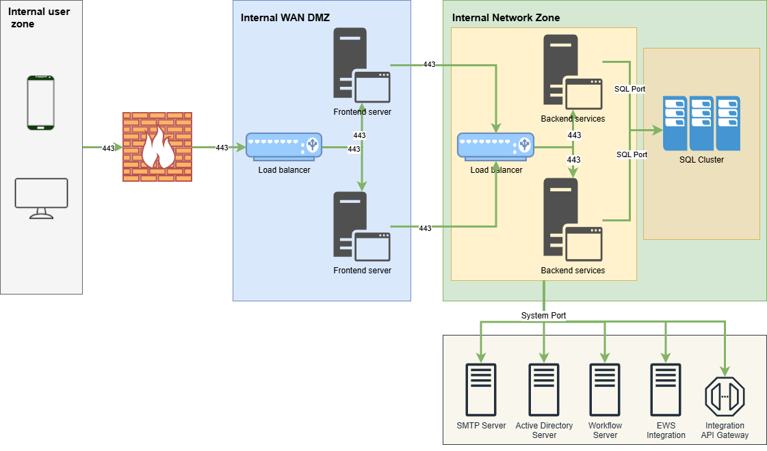

Architecture Design Description - Concise three-tier architecture overview
User Access:
- Internal users (using HTTPS requests) will access the system through the frontend load balancer (WAF F5).
Frontend Layer:
- The frontend load balancer (WAF F5) distributes incoming requests across the frontend servers.
Backend Layer:
- The frontend servers forward requests to the backend load balancer (WAF F5), which in turn routes them to the backend servers.
- Two primary service groups:
  - Backend Services: Core business logic and API services
  - Workflow Services: Process orchestration and workflow management
Backend Server Connectivity:
Each backend server maintains connections with:
- SQL Cluster (via SQL Port):
  - SQL Server Always On Availability Group with automatic failover
- SMTP Server (via System Port):
  - Email notification delivery and processing
- Active Directory Server (via System Port):
  - User authentication and authorization via LDAP/LDAPS
- Integration API Gateway (via System Port):
  - Integration with other systems
- Integrate with Microsoft Exchange Web Services (EWS):
- Retrieve unread email count.
- Retrieve calendar events for a given time window (e.g., today/next 7 days) with essential metadata.

EWS integration
- Consumer Apps
- backend services that need unread counts and calendar events.
- Identity / Access
- Service account + EWS Impersonation (AD user) (e.g., svc_ews_reader)
- Exchange (On-Prem)
- EWS endpoint: https://<exchange-fqdn>/EWS/Exchange.asmx

Pre-prod/Stage/Test/Dev Environments can be based on your Policy.
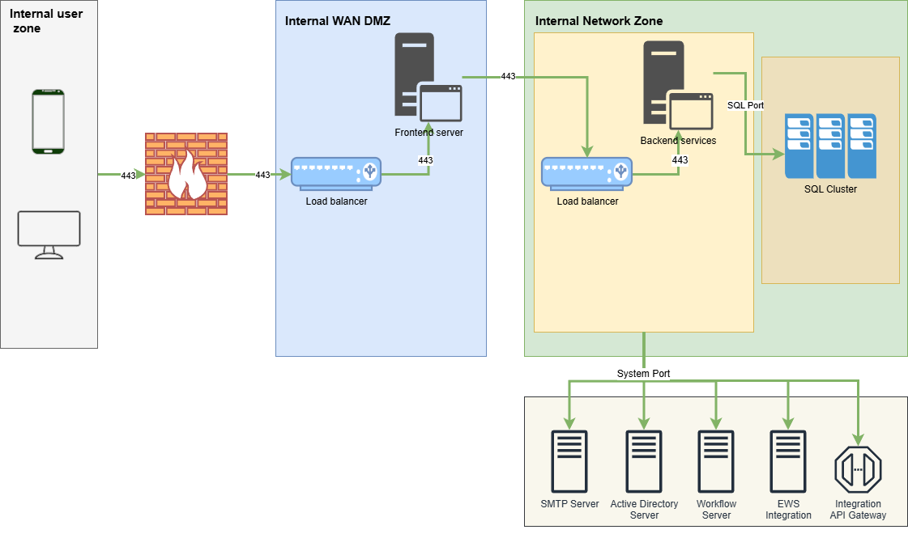

2.2 Modules
Describe the Key System modules and their interactions
Core System Modules - key modules with brief descriptions:
- User Interface Module
Responsive web interface for all users; all system modules are accessed through this UI.
- Administrative Affairs Service Module
Manages correspondence, fax, seals, and printing services; integrates with Notification and Workflow for approvals and updates.
- Human Resources Service Module
Handles clearance, promotions, transfers, and workforce planning; integrates with Notification and Workflow for HR processes.
- Security Protection Service Module
Manages material tracking and access control; integrates with Notification and Workflow for secure approvals.
- Printing Press Service Module
Oversees printing requests, business cards, and stamps; integrates with Notification and Workflow for request handling.
- Relations Protocol Service Module
Manages protocol services and official visits; integrates with Notification and Workflow for scheduling and approvals.

- Achievement Service Module
Tracks strategic programs and organizational achievements; integrates with Notification and Workflow for reporting cycles.
- Task Management Module
System for tasks, assignments, and project tracking; integrates with Notification and Workflow for task lifecycle management.
- Notification Service Module
Central hub for email, SMS, and in-app alerts; supports all modules with real-time communication.
- Workflow Module
Designs and manages workflows for approvals and processes; integrates with all functional modules.
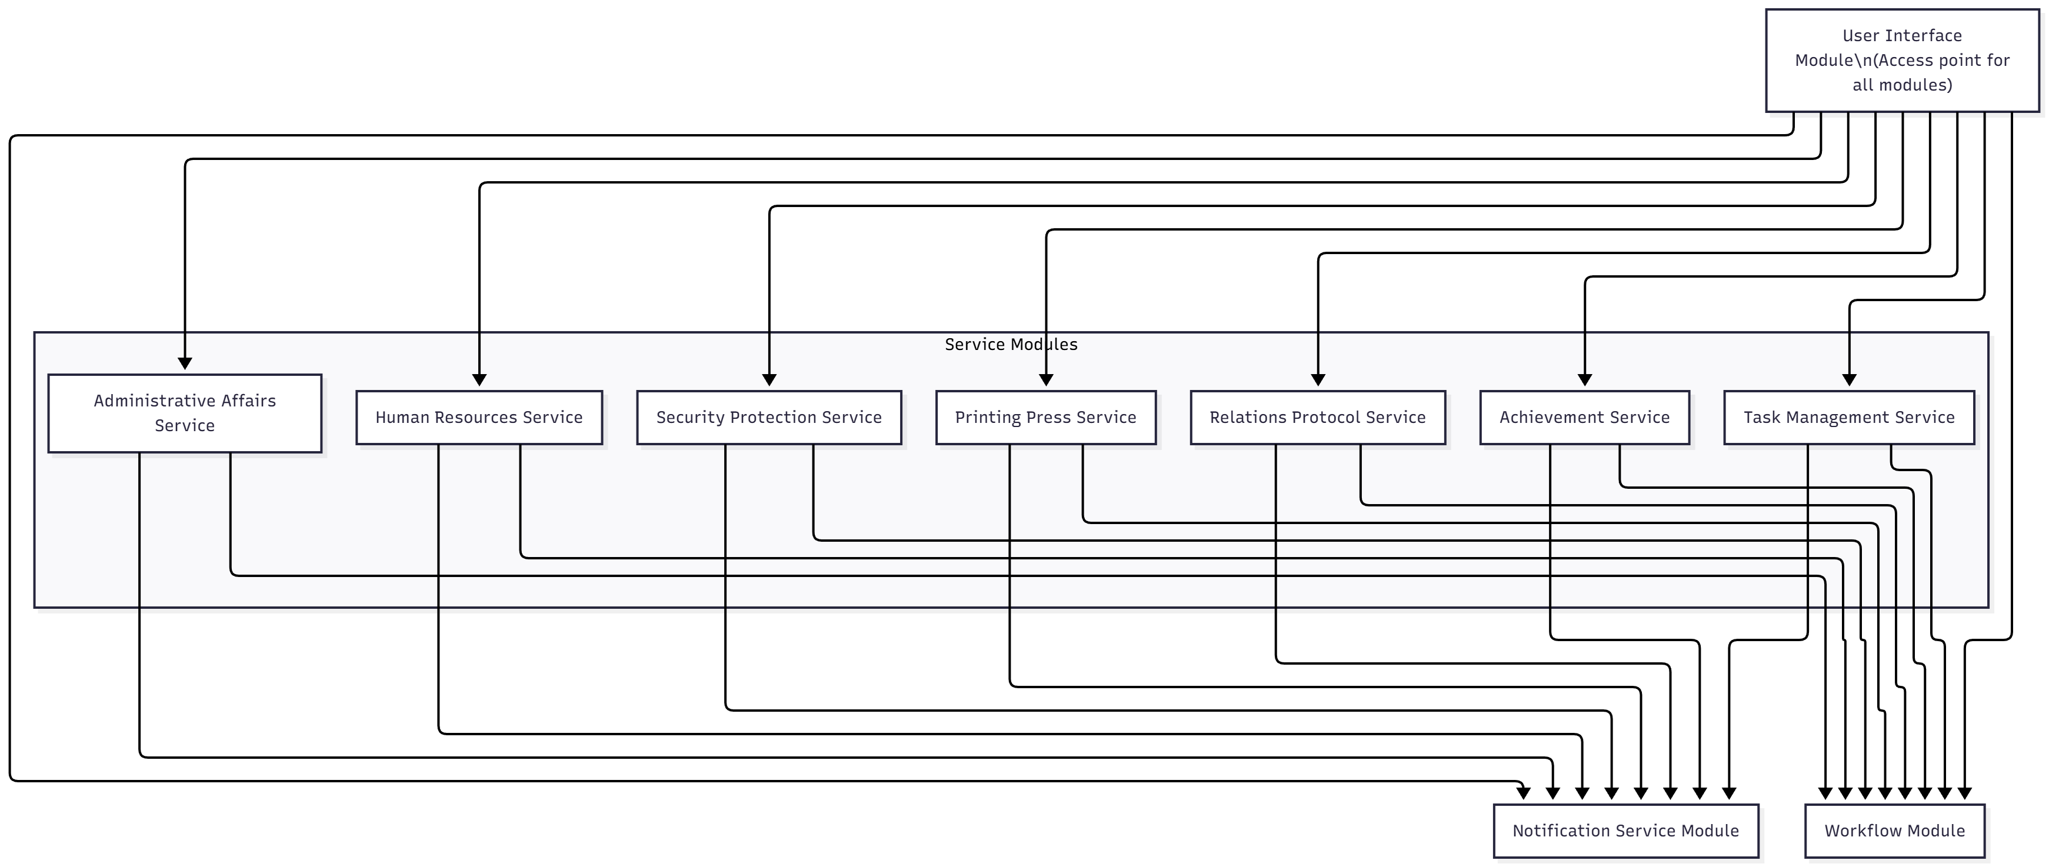
2.3 System Workflow
Describe the Key System workflows and sequence diagrams
Sample of system workflow
Workflow 1: User Authentication and Login
This workflow handles user authentication through Active Directory and session establishment.
Steps:  - User accesses the portal  - System checks authentication status  - If not authenticated, login page is displayed  - User enters Active Directory credentials  - System validates credentials against AD  - Upon success, user profile is retrieved/synchronized  - JWT token is generated for API access  - Token stored in cookie for session persistence  - User redirected to dashboard | 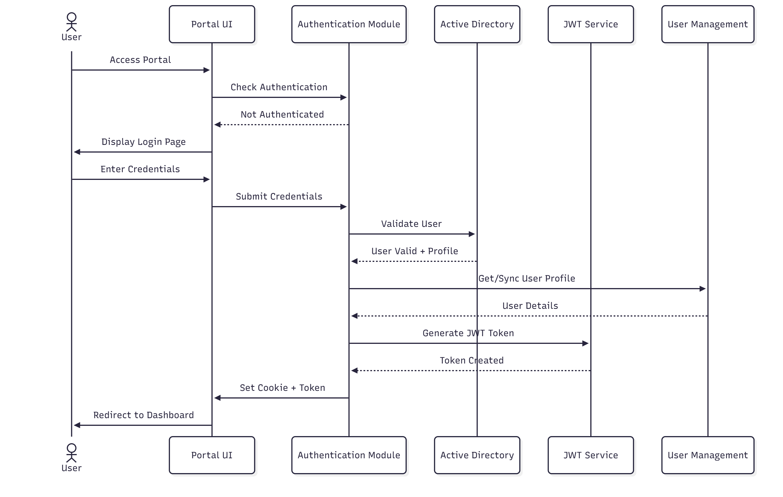
Workflow 2: Service Request Submission
This workflow describes how users submit service requests through the portal.
Steps:  - User navigates to service request form  - System loads dropdown options (departments, types, priorities)  - User completes form and attaches documents  - Request submitted to eServices API.  - Gateway validates user authentication (JWT token)  - Request routed to appropriate domain service (HR, RP, SP, etc.)  - Service validates business rules  - Request saved to service-specific database  - Workflow automatically created task in the system  - Notifications sent to approvers/assignees  - Confirmation returned to user | 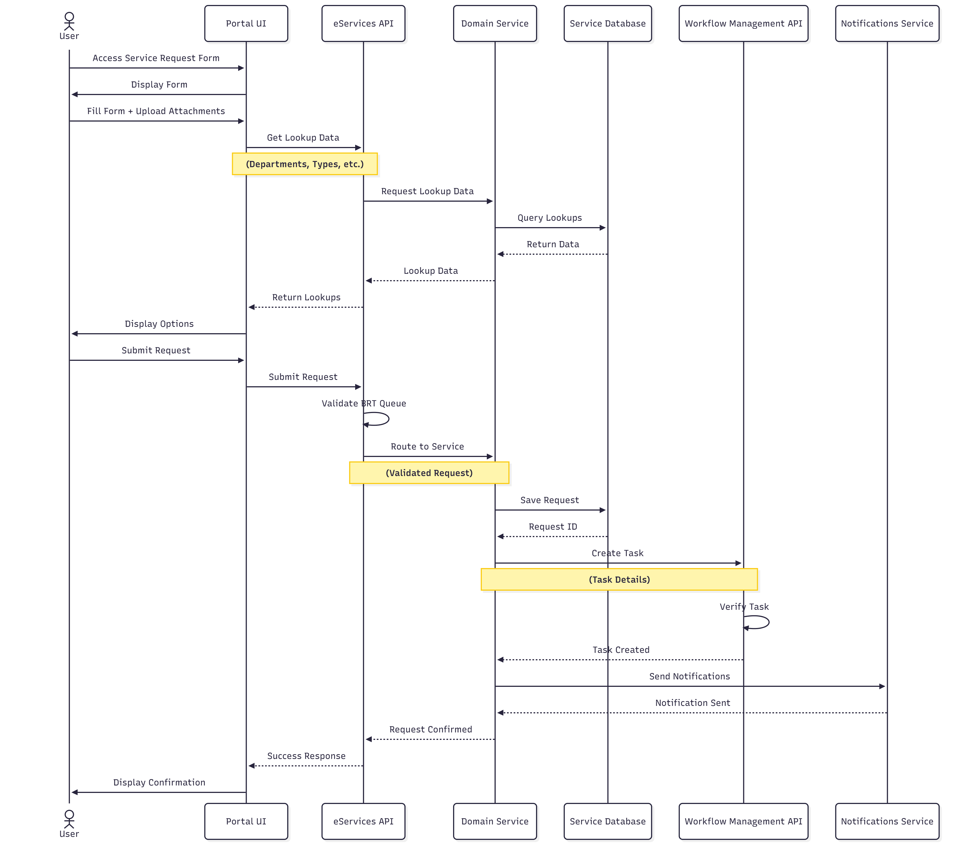

2.4 Integration and Interfaces
Define the internal and External Interfaces required for the system
- Integration with Internal Systems - The solution will integrate with internal systems including:
  - Active Directory (AD) for authentication and user management
  - Mail Server (Exchange/SMTP) for email notifications
  - HR Information System (HRIS) for employee data synchronization
  - Any other future system(API gateway, SSO, Watheq, Document management system etc).

2.5 Error Handling and Logging
Error Handling: Describe the error handling strategy, including how exceptions or failures will be handled.
Logging: Provide guidelines for logging (e.g., types of events to log, log format, tools used for log aggregation).
The system uses Exception Middleware to handle all errors centrally.
How it works:
- Middleware catches all unhandled exceptions
- Logs the error using Serilog
- Returns user-friendly error message
- Application continues running
Log Storage
Logs are stored in shared network drive:
- Path: \\MOD-FileServer\ AppLogs\eServicesPortal\
2.6 User Interface (UI) Design
Describe the UI Design
UI Overview: Provide a high-level description of the user interface, including major screens and flow.
Overall Design Approach: The UI(ASP.NET Core MVC Razor Views) follows a modern, clean design with government-appropriate styling that incorporates Saudi Ministry of Defense branding.
Core Interface Structure:
- Header Bar: Contains MOD logo, portal title, user profile, and logout options
- Navigation Sidebar: Provides access to all service categories and task management functions
- Main Content Area: Displays dynamic content based on user selections
- Footer: Contains system information and support links
Screen Flow Diagram

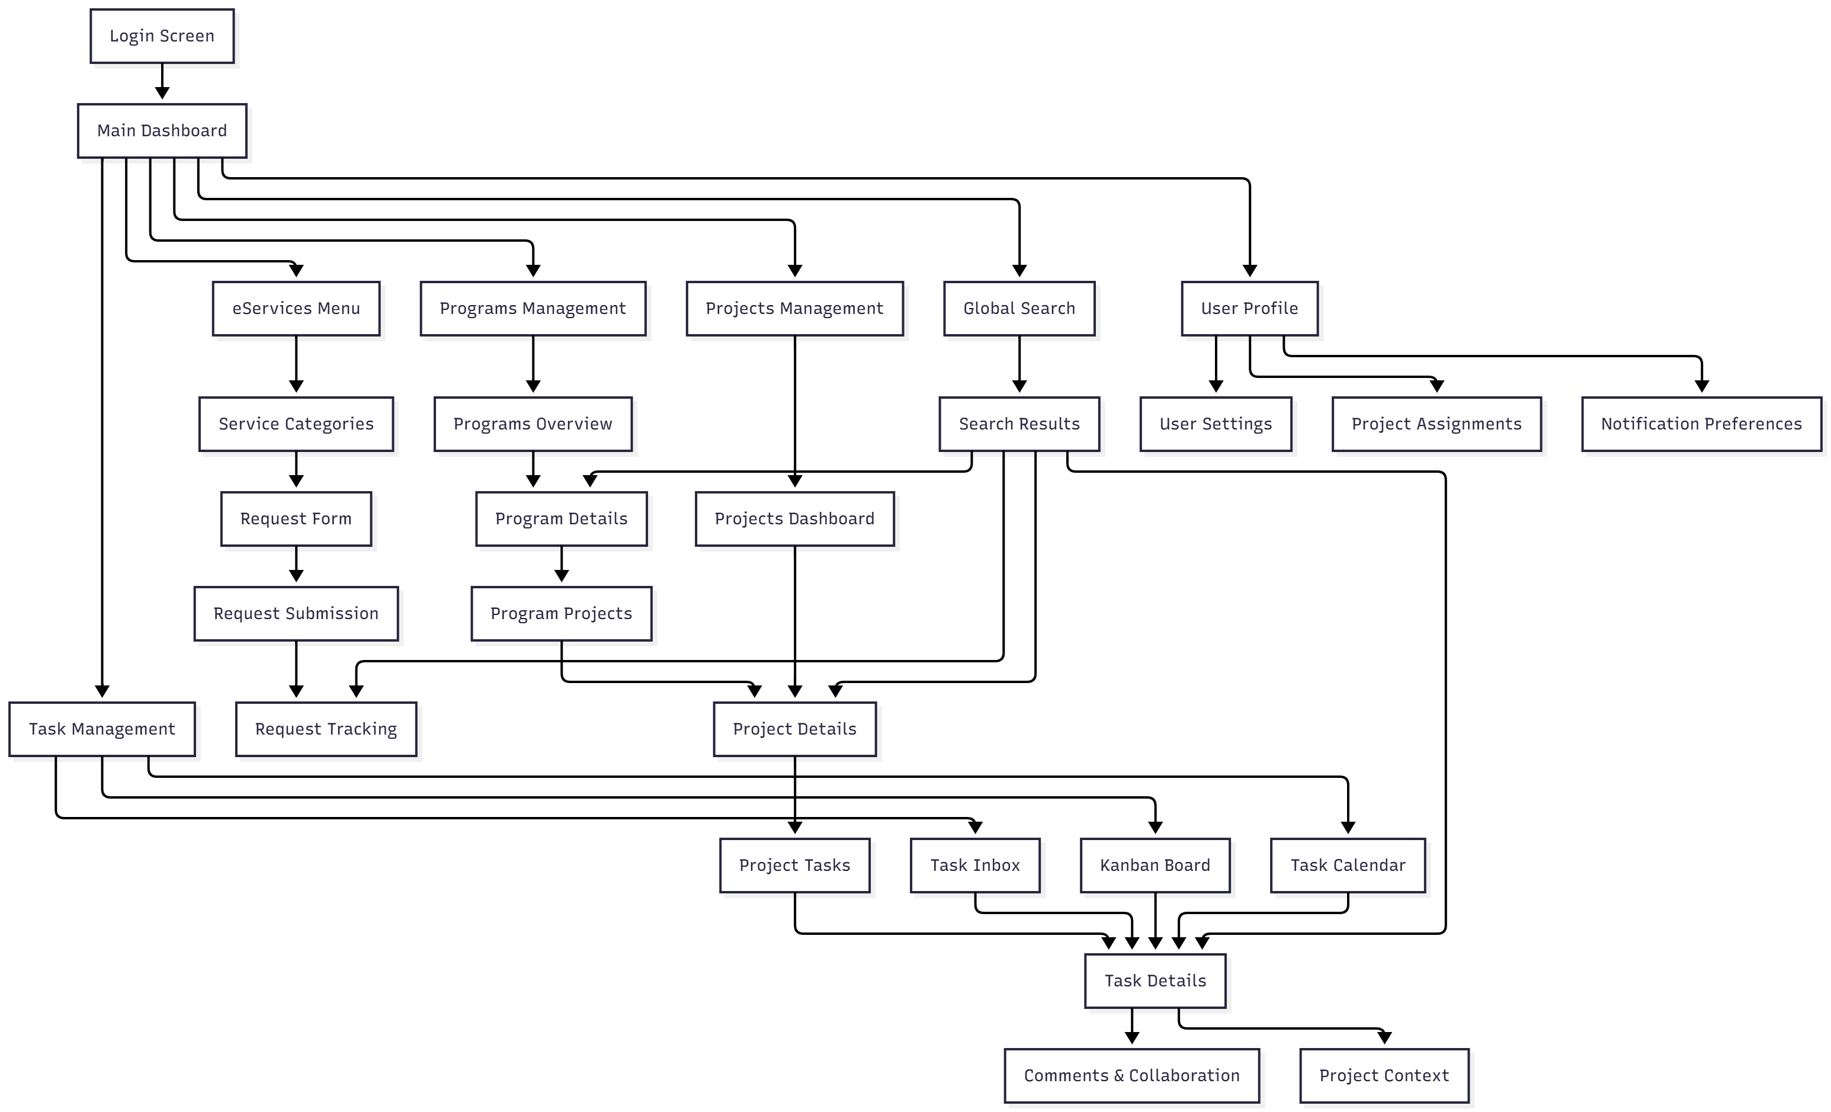
Wireframes/Mockups: Attach wireframes or mockups for key UI elements.
https://www.figma.com/proto/aBeTSzL97DTPwD3Ne4dIep/MOD-eServices?page-id=0%3A1&node-id=1-66096&p=f&viewport=127%2C16%2C0.06&t=AMGQq0SlKXpe4ib9-1&scaling=min-zoom&content-scaling=fixed&starting-point-node-id=1%3A66096

Usability Considerations: Describe any UX best practices being followed.

2.7 Operational Model View
Defines the distribution of the System’s components onto zones, together with the VLANs necessary, and the deployment of components supported by each zone, to enable the required component interactions in order to achieve the functional and non-functional requirements within the constraints of technology
Provide for Dev, Pre-prod, and Prod
Overall Deployment Architecture
The system employs a multi-tier, zone-based deployment model with clear separation of concerns across network security zones. Each environment (Dev, Pre-prod, Prod) follows the same architectural pattern with varying security controls and resource allocation.
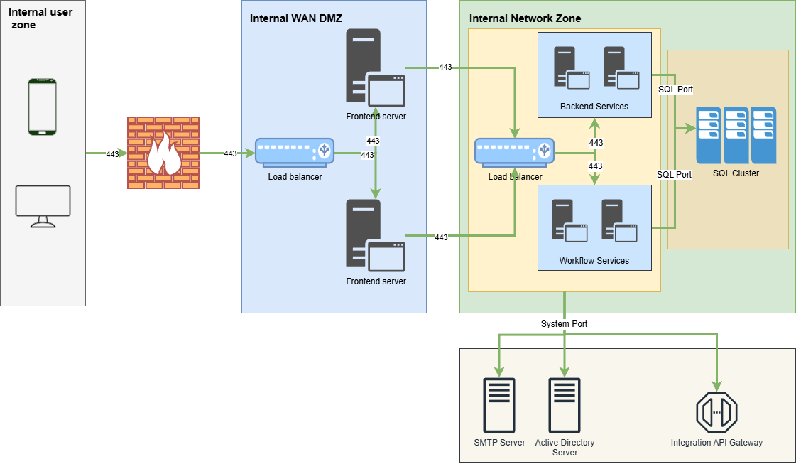

2.8 Data Architecture View
A description for the system persistent data storage perspective, this section is optional if there is little or no persistent data or the translation between the Design Model and the Data Model is trivial.
Explain the expected traffic flow of data explaining the interaction between all elements and Zones, supported by applied security controls. Expected concurrent sessions and throughput
Database Architecture: Describe the overall database structure and any key data models.
The system employs a microservices-oriented database architecture where each service module has its own dedicated database to ensure data isolation, independent scalability, and service autonomy.
Database Technology:
- Platform: Microsoft SQL Server 2019/2022 Enterprise Edition
- Clustering: Always On Availability Groups for high availability
- Backup: Automated daily full backups with 4-hour incremental backups
- Encryption: Transparent Data Encryption (TDE) enabled

Data Flow: Provide an overview of how data will flow through the system (e.g., user inputs, API calls, database queries).
Overall Data Flow Pattern
User Input → Frontend Validation → API → Service Layer → Business Logic & Validation → Repository Layer → Database
Sample:
1. Service Request Submission:
User fills form → Client-side validation → Submit to API
↓
API validates JWT → Route to Service Module
↓
Service validates business rules → Save to eServicesPortal_DB
↓
Create task in TaskManagement_DB
↓
Queue notification in Notifications_DB
↓
Return confirmation to user

Data Storage: Specify what kind of databases or storage systems will be used (e.g., relational, NoSQL, file storage).
The MOD eServices Portal utilizes a Relational Database (SQL Server) data architecture with persistent storage across multiple data models to support service requests, task management, user information, and system operations.

Data Integrity and Validation: Outline how data consistency and validation will be handled.

Communication Requirements Matrix
Initiator | Initiator IP/Subnet | Receiver | Receiver IP/Subnet | Protocol | Port
User | Internal users zone | Firewall | Firewall | TCP | 443
Firewall | Firewall | FE Load balancer | Internal WAN DMZ | TCP | 443
FE Load balancer | Internal WAN DMZ | Frontend Server 1 | Internal WAN DMZ | TCP | 443
FE Load balancer | Internal WAN DMZ | Frontend Server 2 | Internal WAN DMZ | TCP | 443
Frontend Server 1 | Internal WAN DMZ | BE Load balancer | Internal Network Zone | TCP | 443
Frontend Server 2 | Internal WAN DMZ | BE Load balancer | Internal Network Zone | TCP | 443
BE Load balancer | Internal Network Zone | Backend servers | Internal Network Zone | TCP | 443
BE Load balancer | Internal Network Zone | Workflow Servers | Internal Network Zone | TCP | 443
Backend servers | Internal Network Zone | Database/External systems | Internal Network Zone | TCP | 443
Workflow Servers | Internal Network Zone | Database/External systems | Internal Network Zone | TCP | 443

2.9 Solution – Non-Functional Views
The views and information that provides how NFRs are Met.
Solution Security View:
The solution uses a firewall to control network access, a WAF to protect against web attacks, role-based authorization to restrict access by user roles, and LDAP authentication to securely verify user identities.

Solution Availability View:
The solution is highly available, using two nodes behind a load balancer (WAF F5) on both backend and frontend to ensure continuous service and failover support

Solution Management and Monitoring View:
The solution provides logging for tracking system events and an audit trail to monitor user actions, enabling effective management and accountability.

Solution Sizing and Performance View :
How the system will handle increased loads (e.g., horizontal scaling, load balancing).
Performance Considerations: Discuss how the system will meet performance requirements (e.g., response time, throughput).
Caching Strategy: If applicable, mention caching layers or strategies for improving performance

3. Risks and Mitigation Strategies
Identify any potential risks that could impact the success of the system (e.g., technology risk, security risk, scalability).
Describe strategies to mitigate these risks.
- Risk: Single points of failure
Impact: Service downtime or system unavailability
Mitigation: Implement high availability configurations with redundant nodes and failover mechanisms.
- Risk: Database loss
Impact: Loss of critical data and potential service disruption
Mitigation: Perform regular full backups and ensure backup integrity
- Risk: Unauthorized access / data breach
Impact: Exposure of sensitive data, regulatory compliance issues
Mitigation: Enforce role-based access control and strong authentication mechanisms
- Risk: Malicious or invalid file uploads
Impact: Potential security breaches, application compromise
Mitigation: Use WAF and application whitelisting to validate and restrict file uploads

Approvals

Technology Expert, Role 1  Signature: _______________________________ | Date__________
Technology Head  Signature: _____________________________ | Date__________
Technology Director  Signature: _____________________________ | Date__________

